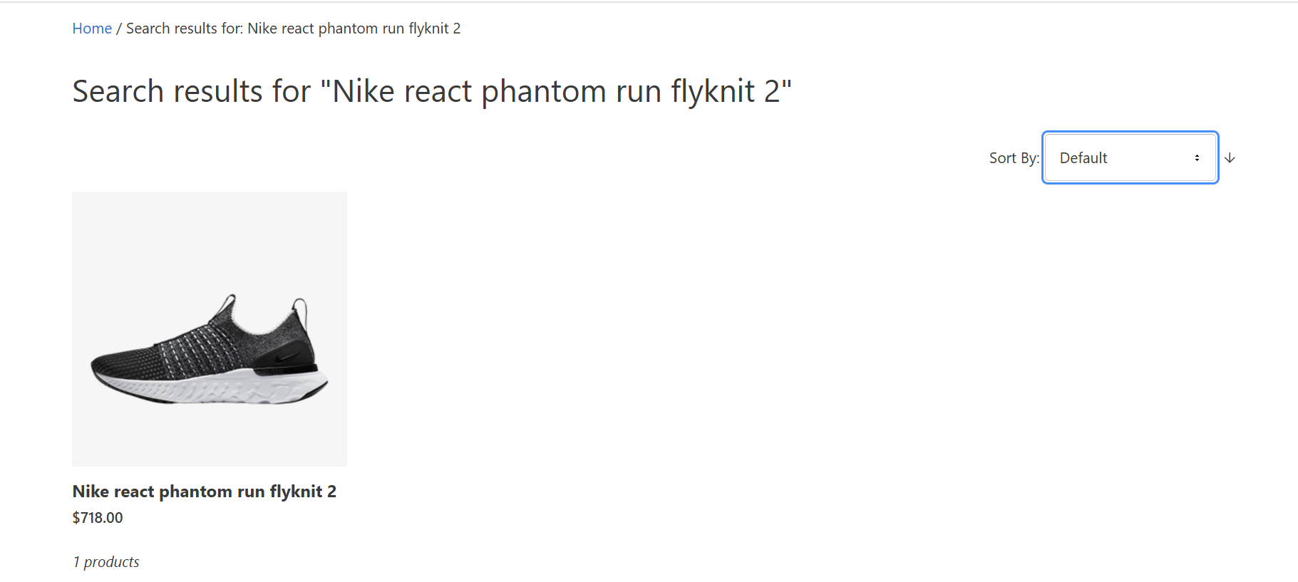

Test Id 5 : All filters are not showing in the search result page. It should have brands , price range and size .